Co-Chair  Vernon Sykes, Representative  34th House District | 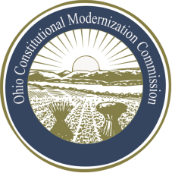 | Co-Chair  William G. Batchelder, Speaker  69th House District
Ohio Constitutional Modernization Commission

Judicial Branch & the Administration of Justice Committee
Janet Abaray, Chair
Thursday, June 13, 2013

Chairwoman Abaray called the Ohio Constitutional Modernization Committee on the Judicial Branch and the Administration of Justice to order at 9:31 AM and asked the clerk to call the roll.

The committee attendees included: Janet Abaray, Patrick Fischer, Judi French, Charles Kurfess, Dennis Mulvihill, Dennis Murray, Larry Obhof, Richard Saphire, Michael Skindell, and Richard Walinski. William Batchelder was not present at committee.

Following roll call, the committee preceded with its first order of business.

Chairwoman Abaray called Mary Jane Trapp, Counsel of Thrasher, Dismore, and Dolan, to give a presentation on the history of the Ohio Constitutional Convention.

Following the completion of Mary Jane Trapp’s presentation, Chairwoman Abaray called William Weisenberg, Assistant Executive Director of the Ohio State Bar Association, to give a presentation on judicial selection and the 1970 Ohio Constitutional Convention.

Chairwoman Abaray invited William Weisenberg to come to the next committee meeting as time ran short.

Following the invitation Chairwoman Abaray adjourned at 11:14 AM.

Janet Abaray, Chair | Patrick Fischer, Vice Chair

